Lab 3: File Management and User Input

- Answer all of the following questions. Questions are given in bold italics.
- Save all your answers in a file named YourFirstNameYourLastName.doc (or the appropriate file extension). Upload this file to Blackboard.

- Create a directory called Lab3 in your home directory.

(Remember Linux is case sensitive.)
What is the command you used to create this directory?

- Change directory to the directory you just created.
Create a file called test.txt in the Lab3 directory.
Using mv, rename test.txt to test2.txt.

List the command you used to perform this renaming.
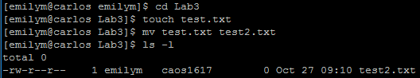

- Make a new directory called testdir in the Lab3 directory.
Use the cp command to copy the file test2.txt to the new file test_copy.txt in the ~/Lab3/testdir directory. (Remember ~ is your home directory.)

List the cp command you used to do this.
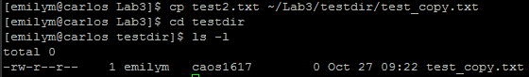

- Create the following empty files in Lab3 directory:

FileA1.jpg,
FileA2.txt,
FileB1.jpg,
FileB2.txt.

What command would you use to list only files beginning with FileA?

- What command would you use to delete only files ending with txt?
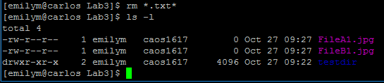

- Delete all the files in the Lab3 directory. Use only one command; do not delete each file separately.

What command did you use?
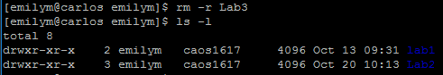

- In the Lab3 directory, create the following empty files:
FileA1.txt,
FileA2.txt,
FileB1.txt,
FileB2.txt,
FileC1.txt,
FileC2.txt.

What command can be used to list only files which begin
with FileA or FileB ? Note: Use one ls command only.

- Write a script called filerename.sh.
The script prompts the user to enter the name of a file to be renamed, then prompts the user for the target name and finally renames the file.
List the contents of your script or attach a screen shot of your script here.

